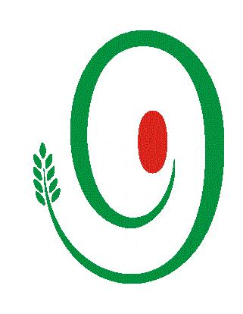

Navdanya
BHOOMI, MAATI MA: THE FESTIVAL OF THE LIVING SOIL
Thursday, October 1, 2015
The Auditorium, India International Centre,
40, Maxmueller Marg, Lodhi Road, New Delhi - 110003

REGISTRATION

My confirmed details (please write in capital letters):

Name: ____________________________________________

Designation:-____________________________________________

Organisation:____________________________________________

Address (office): _______________________________________

___________________ Pin Code: ____________

Telephone: ________________________Fax: _________________
(Landline & mobile)

Email: __________________________________________________

Address (Res): _________________________________________

_________________________PIN:_____________

Telephone: ______________________________
(Landline & mobile)

Area of Interest and Confirmation

Exhibition on The Living Soil in Gandhi King Plaza 11:00-06:00pm
Film on The Living Soil by The Tadpole Artist Collective 10:40-11:00pm

□ Session 1: The Living Soil 10: 40-01:30pm
□Lunch : 01:30 pm to 02:30 pm
□ Mud people by Space Theatre Ensemble & Jazz musician Steve Siqueria 02:30-03:30pm
□Session 2: The Culture of The Living Soil 03:30-04:30pm
□ Session 3: The Living Soil & Earth Democracy 04:30-05:30pm

Tea 05:30-06:00 pm
□Cultural evening: Music from the soil at 6:00 pm to 8: 00 pm
□ Dinner Navarasa: The Diverse Colours, Aromas & Tastes of Food (on prior booking), 8:00pm

□ I would like to be kept informed, for more information: www.navdanya.org
NAVDANYA, A-60 Haus Khas, New Delhi 110016 Tel: 011-26968077, 40793568, 40793568 Fax: 011-26856795 Email: festivals@navdanya.net

